 |  | 14
 |  | 24
 |  | 14
 |  | 45
 |  | 14
 |  | 13
 |  | 34
 |  | 24
 |  | 15
 | 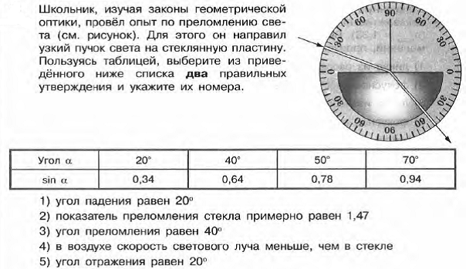 | 23
 | 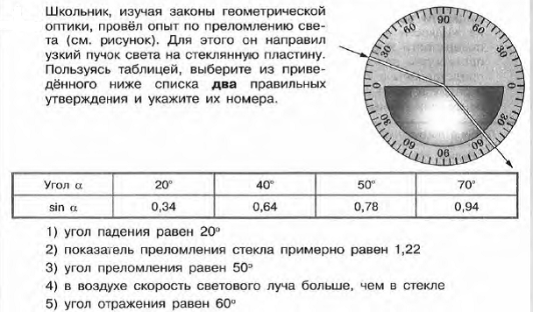 | 34

